**Stat 5100 Handout #21 – SAS: Variations on Ordinary Least Squares**

**(Weighted Least Squares, Robust Regression, Nonlinear Regression)**

Example 1: (Weighted Least Squares) A health researcher is interested in studying the relationship between diastolic blood pressure (bp) and age in adult women. Data are reported on 54 healthy adult women.

**/* Read in the data (Table 11.1) */**

**data bpexample; input age bp @@; cards;**

**27 73 21 66 22 63 24 75 25 71 23 70**

**20 65 20 70 29 79 24 72 25 68 28 67**

**26 79 38 91 32 76 33 69 31 66 34 73**

**37 78 38 87 33 76 35 79 30 73 31 80**

**37 68 39 75 46 89 49 101 40 70 42 72**

**43 80 46 83 43 75 44 71 46 80 47 96**

**45 92 49 80 48 70 40 90 42 85 55 76**

**54 71 57 99 52 86 53 79 56 92 52 85**

**50 71 59 90 50 91 52 100 58 80 57 109**

**;**

**/* Try OLS */**

**proc reg data=bpexample;**

**model bp = age;**

**title1 'OLS model fit';**

**output out=out1 p=pred r=resid;**

**run;**

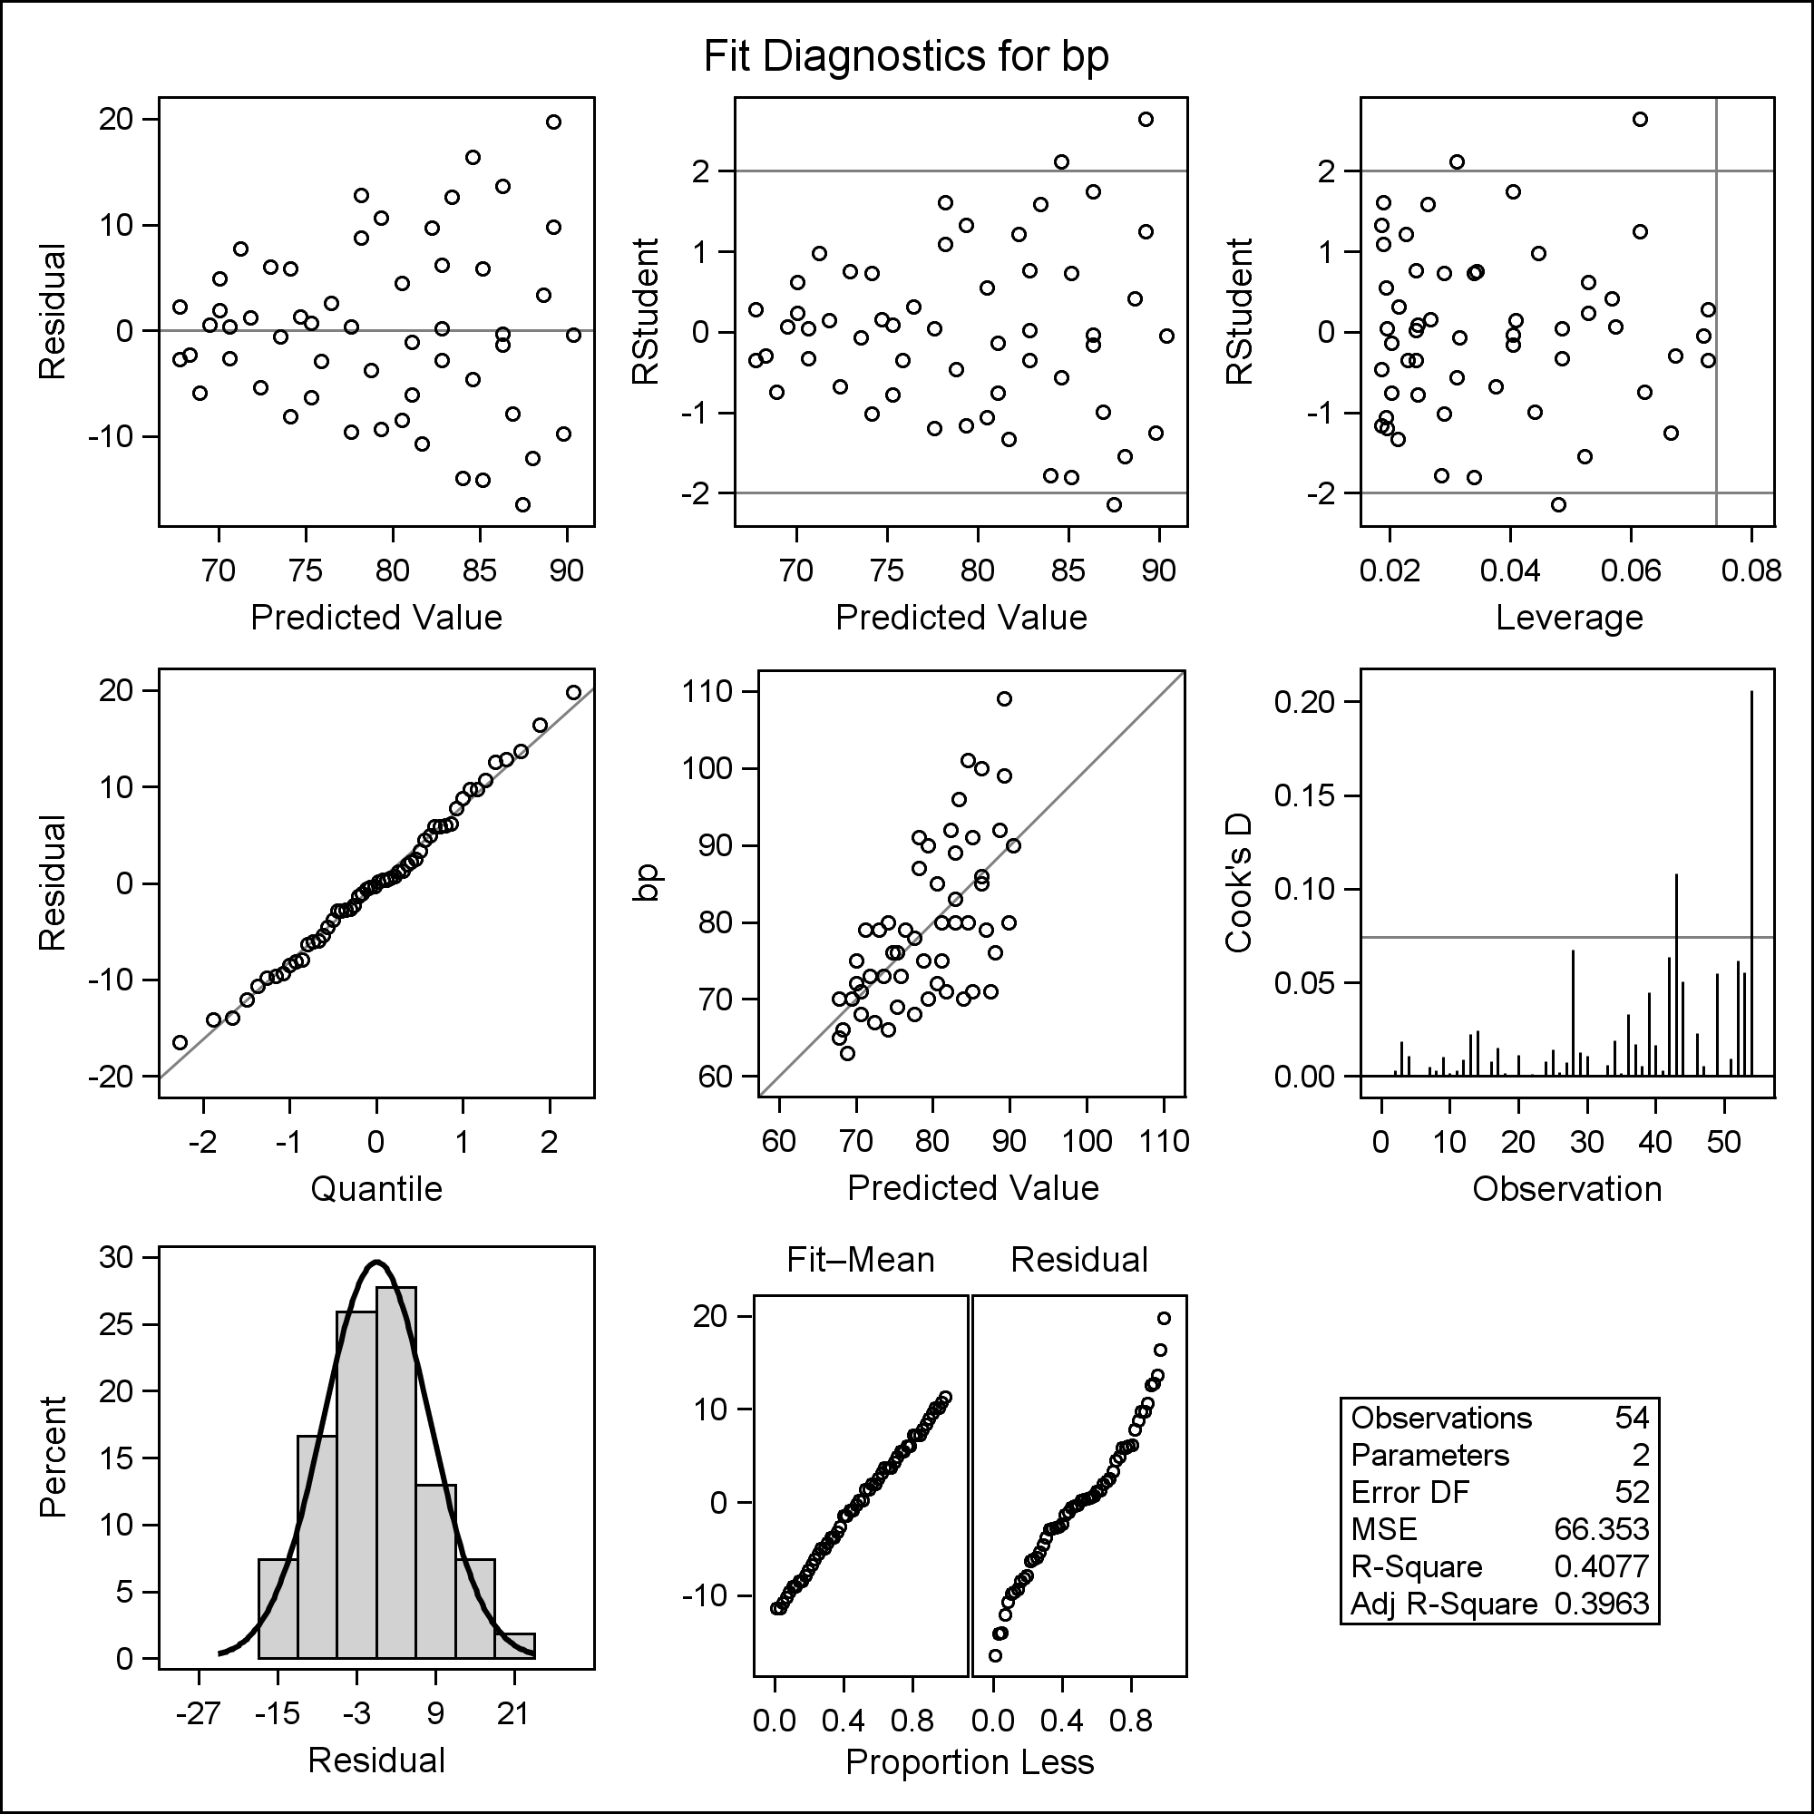

**/* Use resid_num_diag macro from**

**http://www.stat.usu.edu/jrstevens/stat5100/resid_num_diag_1line.sas**

**\*/**

**%macro resid_num_diag(dataset,datavar, ...**

**%*resid_num_diag*(dataset=out1, datavar=resid,**

**label='residual', predvar=pred, predlabel='predicted');**

**run;**

|  |  |  |  |  |  |  |  |  |
| --- | --- | --- | --- | --- | --- | --- | --- | --- |
| |  | | --- | | ***P-value for Brown-Forsythe test of constant variance*** | | ***in residual vs. predicted*** |  | **Obs** | **t_BF** | **BF_pvalue** | | --- | --- | --- | | **1** | 2.78547 | .007440565 | |

**/* Look for relationship between SD of resid and X */**

**data out1; set out1;**

**abs_resid = abs(resid);**

**proc sgplot data=out1;**

**scatter x=age y=resid / markerattrs=(symbol=CIRCLEFILLED);**

**xaxis labelattrs=(size=20pt);**

**yaxis labelattrs=(size=20pt);**

**run;**

**proc sgplot data=out1;**

**scatter x=age y=abs_resid / markerattrs=(symbol=CIRCLEFILLED);**

**xaxis labelattrs=(size=20pt);**

**yaxis labelattrs=(size=20pt);**

**run;**

|  |  |
| --- | --- |
|  |  |

**/* Get estimate of SD of resid based on X */**

**proc reg data=out1 noprint;**

**model abs_resid = age;**

**output out=out2 p=estSD;**

**run;**

**/* Define weight */**

**data out2; set out2;**

**useWeight = 1/estSD**2;**

**run;**

**/* Fit WLS model */**

**proc reg data=out2;**

**model bp = age;**

**weight useWeight;**

**title1 'WLS model fit';**

**run;**

|  |  |  |  |  |  |  |  |  |  |  |  |  |  |  |  |  |  |  |  |  |  |  |  |  |  |
| --- | --- | --- | --- | --- | --- | --- | --- | --- | --- | --- | --- | --- | --- | --- | --- | --- | --- | --- | --- | --- | --- | --- | --- | --- | --- |
| |  | | --- | | ***WLS model fit*** |      | **Parameter Estimates** | | | | | | | --- | --- | --- | --- | --- | --- | | **Variable** | **DF** | **Parameter Estimate** | **Standard Error** | **t Value** | **Pr > |t|** | | **Intercept** | **1** | 55.56577 | 2.52092 | 22.04 | <.0001 | | **age** | **1** | 0.59634 | 0.07924 | 7.53 | <.0001 | |

Example 2: (IRLS; recall Handout #2 example) As part of a cost improvement program, the Toluca company wished to better understand the relationship between the lot size (X) and the total work hours (Y).

**/* Input data -- recall Ch. 1 example */**

**data toluca; input lotsize workhours @@; cards;**

**80 399 30 121 50 221 90 376 70 361 60 224**

**120 546 80 352 100 353 50 157 40 160 70 252**

**90 389 20 113 110 435 100 420 30 212 50 268**

**90 377 110 421 30 273 90 468 40 244 80 342**

**70 323**

**;**

**run;**

**/* Look at original data */**

**proc sgplot data=toluca;**

**scatter x=lotsize y=workhours / markerattrs=(symbol=CIRCLEFILLED);**

**xaxis labelattrs=(size=15pt);**

**yaxis labelattrs=(size=15pt);**

**title1 height=2 'Toluca -- Original Data';**

**run;**

**/* To show effect of robust regression, look at**

**'contaminated' data */**

**data contam; set toluca;**

**if workhours > 500 then workhours = workhours*3;**

**proc sgplot data=contam;**

**scatter x=lotsize y=workhours / markerattrs=(symbol=CIRCLEFILLED);**

**xaxis labelattrs=(size=15pt);**

**yaxis labelattrs=(size=15pt);**

**title1 height=2 'Toluca -- Contaminated Data';**

**run;**

|  |  |
| --- | --- |
|  |  |

**/* Look at shape of bisquare weighting curve */**

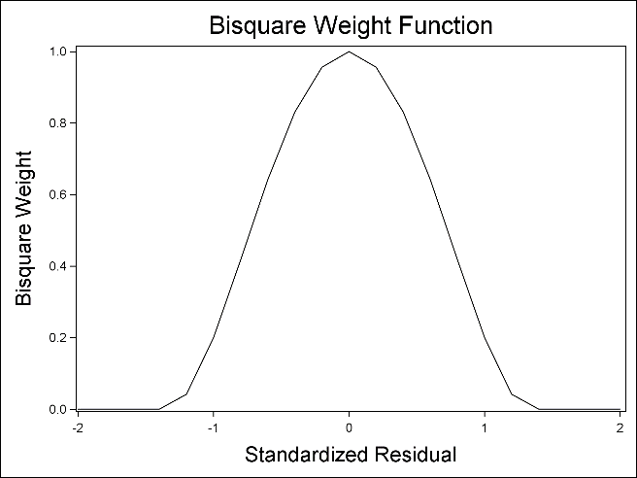**data temp; input u @@; cards;**

**-2.0 -1.8 -1.6 -1.4 -1.2**

**-1.0 -0.8 -0.6 -0.4 -0.2**

**0 0.2 0.4 0.6 0.8**

**1.0 1.2 1.4 1.6 1.8 2.0**

**;**

**data temp; set temp;**

**c = 1.345;**

**w = (1-(u/c)**2)**2;**

**if abs(u) >= c then w = 0;**

**proc sgplot data=temp;**

**series x=u y=w;**

**yaxis label='Bisquare Weight' labelattrs=(size=15pt);**

**xaxis label='Standardized Residual' labelattrs=(size=15pt);**

**title1 height=2 'Bisquare Weight Function';**

**run;**

**/* OLS regression on original data */**

**proc reg data=toluca;**

**model workhours = lotsize;**

**output out=out2 p=pred2;**

**title1 'Regression on original data';**

**run;**

| **Parameter Estimates** | | | | | |
| --- | --- | --- | --- | --- | --- |
| **Variable** | **DF** | **Parameter Estimate** | **Standard Error** | **t Value** | **Pr > |t|** |
| **Intercept** | **1** | 62.36586 | 26.17743 | 2.38 | 0.0259 |
| **lotsize** | **1** | 3.57020 | 0.34697 | 10.29 | <.0001 |

**/* OLS regression on response-contaminated data */**

**proc reg data=contam;**

**model workhours = lotsize;**

**output out=out3 p=pred3;**

**title1 'Regression on response-contaminated data';**

**run;**

| **Parameter Estimates** | | | | | |
| --- | --- | --- | --- | --- | --- |
| **Variable** | **DF** | **Parameter Estimate** | **Standard Error** | **t Value** | **Pr > |t|** |
| **Intercept** | **1** | -86.98444 | 120.90818 | -0.72 | 0.4791 |
| **lotsize** | **1** | 6.32778 | 1.60259 | 3.95 | 0.0006 |

**/* Robust (M) regression on response-contaminated data */**

**proc robustreg data=contam method=M (wf=bisquare);**

**model workhours = lotsize;**

**output out=out4 p=pred4;**

**title1 'Robust (M) regression on response-contaminated data';**

**run;**

| **Parameter Estimates** | | | | | | | |
| --- | --- | --- | --- | --- | --- | --- | --- |
| **Parameter** | **DF** | **Estimate** | **Standard Error** | **95% Confidence Limits** | | **Chi-Square** | **Pr > ChiSq** |
| **Intercept** | 1 | 69.2426 | 27.3941 | 15.5511 | 122.9340 | 6.39 | 0.0115 |
| **lotsize** | 1 | 3.4207 | 0.3631 | 2.7091 | 4.1324 | 88.75 | <.0001 |
| **Scale** | 1 | 56.2335 |  |  |  |  |  |

**/* Visualize comparison of methods */**

**data out2; set out2; keep pred2;**

**data out3; set out3; keep pred3;**

**data out4; set out4; keep pred4;**

**data comp; merge contam out2 out3 out4;**

**label pred2 = 'original'**

**pred3 = 'contaminated-OLS'**

**pred4 = 'contaminated-M';**

**proc sort data=comp; by lotsize;**

**proc sgplot data=comp;**

**scatter x=lotsize y=workhours /**

**markerattrs=(symbol=CIRCLEFILLED);**

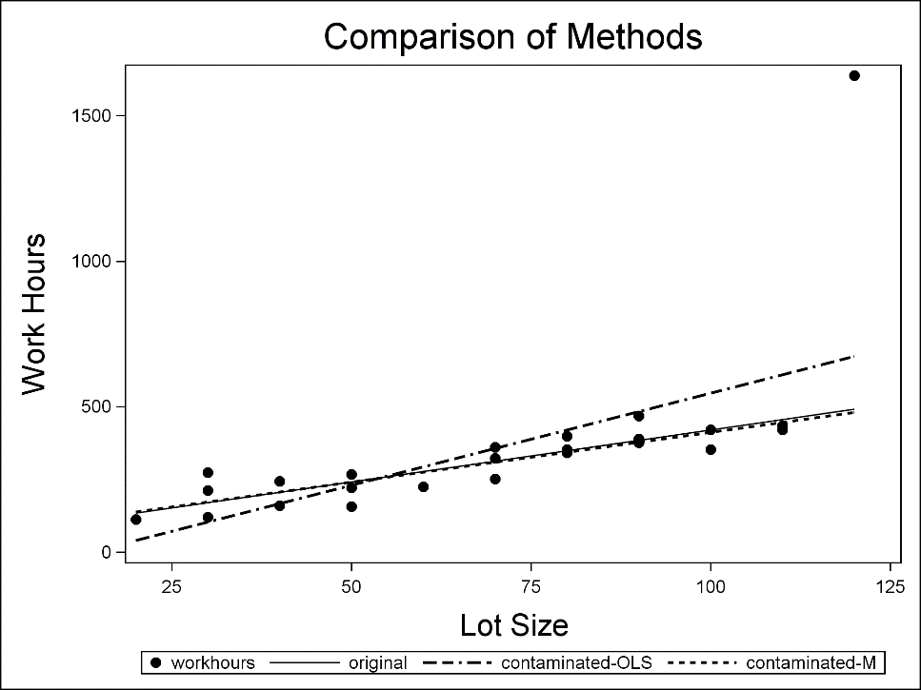 **series x=lotsize y=pred2 /**

**lineattrs=(pattern=1**

**thickness=1);**

**series x=lotsize y=pred3 /**

**lineattrs=(pattern=14**

**thickness=2);**

**series x=lotsize y=pred4 /**

**lineattrs=(pattern=2**

**thickness=2);**

**xaxis label='Lot Size'**

**labelattrs=(size=15pt);**

**yaxis label='Work Hours'**

**labelattrs=(size=15pt);**

**title1 height=2**

**'Comparison of Methods';**

**run;**

Example 3.1: (Nonlinear Regression) Suppose Y = β0 + β1 X1β2 – β3 exp(β4 X2) + ε

|  |  |
| --- | --- |
| **/* Generate random data */**  **data temp;**  **do i=1 to 50;**  **X1 = 10+10*uniform(i);**  **X2 = 1+2*uniform(i+2);**  **error = 10*normal(2*i);**  **output;**  **end;**  **run;**  **/* uniform(A) --> U[0,1]**  **normal(A) --> N(0,1)**  **with seed A**  **\*/**  **/* Define relation */**  **data temp1; set temp;**  **Y=50+10*X1**2-16*exp(2*X2)+error;**  **run;**  **/* Look at plots */**  **proc sgplot data=temp1;**  **scatter x=X1 y=Y / markerattrs=(symbol=CIRCLEFILLED);**  **title1 'Plots of Nonlinear Data';**  **run;**  **proc sgplot data=temp1;**  **scatter x=X2 y=Y / markerattrs=(symbol=CIRCLEFILLED);**  **run;** |  |

**/* Try proc nlin using the default loss function.**

**The result would be the same if the pred and _LOSS_**

**lines were deleted from the code. */**

**proc nlin data=temp1 noitprint maxiter=500;**

**pred = b0 + b1*X1**b2 + b3*exp(b4*X2);**

**_LOSS_ = (Y-pred)**2;**

**model Y = b0 + b1*X1**b2 + b3*exp(b4*X2);**

**parameters b0=100 b1=8 b2=3 b3=-20 b4=4;**

**title1 'proc nlin with [default] squared error loss function';**

**title2 'truth: b0=50, b1=10, b2=2, b3=-16, b4=2';**

**output out=out1 r=resid p=pred;**

**run;**

**/* What if we wanted better fits for smaller predicted values? */**

**\*_LOSS_ = ((Y-pred)/pred)**2;**

|  |  |  |  |  |  |  |  |  |  |  |  |  |  |  |  |  |  |  |  |  |  |  |  |  |  |  |  |  |  |  |  |  |  |
| --- | --- | --- | --- | --- | --- | --- | --- | --- | --- | --- | --- | --- | --- | --- | --- | --- | --- | --- | --- | --- | --- | --- | --- | --- | --- | --- | --- | --- | --- | --- | --- | --- | --- |
| |  | | --- | | ***proc nlin with [default] squared error loss function*** | | ***truth: b0=50, b1=10, b2=2, b3=-16, b4=2*** |  |  | | --- | | NOTE: Convergence criterion met. |      | **Parameter** | **Estimate** | **Approx Std Error** | **Approximate 95% Confidence Limits** | | | --- | --- | --- | --- | --- | | **b0** | 32.9411 | 23.1548 | -13.6950 | 79.5773 | | **b1** | 10.1254 | 0.6771 | 8.7617 | 11.4891 | | **b2** | 1.9970 | 0.0207 | 1.9554 | 2.0387 | | **b3** | -15.5777 | 0.2049 | -15.9904 | -15.1650 | | **b4** | 2.0090 | 0.00450 | 1.9999 | 2.0180 | |

Example 3.2: (Nonlinear Regression) A nonlinear curve to describe sand compression

**data ex2; input p q @@; cards;**

**100 140 200 250 300 350 400 425 500 485 600 530 700**

**560 800 580 900 580 1000 565 1100 535 1200 490 1300**

**425 1400 340 1450 290 1500 225 1550 160 1600 45**

**;**

**proc sgplot data=ex2;**

**scatter x=p y=q / markerattrs=(symbol=CIRCLEFILLED);**

**xaxis labelattrs=(size=15pt);**

**yaxis labelattrs=(size=15pt);**

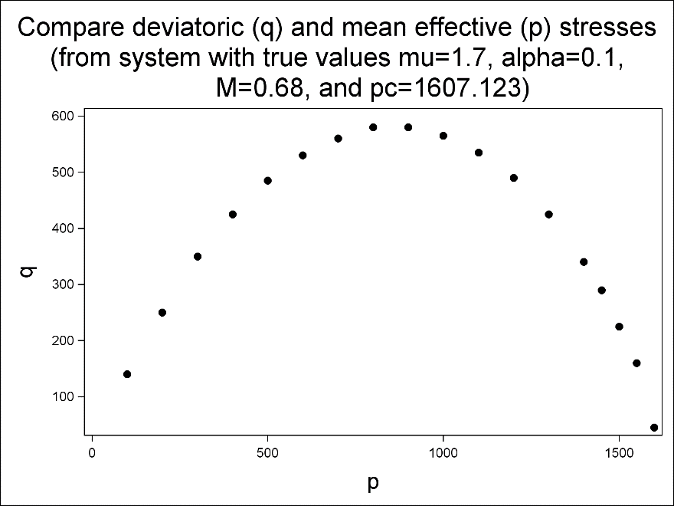 **title1 h=2 'Compare**

**deviatoric (q) and**

**mean effective (p)**

**stresses';**

**title2 h=2 '(from system**

**with true values mu=1.7,**

**alpha=0.1,';**

**title3 h=2 'M=0.68,**

**and pc=1607.123)';**

**run;**

**proc model data=ex2;**

**parms mu 1.7 alpha .2 M .7 ;**

**bounds M mu > 0;**

**control pc 1607.123;**

**k1 = mu*(1-alpha)/(2*(1-mu)) \***

**(1+sqrt(1-4*alpha*(1-mu)/(mu*(1-alpha)**2)));**

**k2 = mu*(1-alpha)/(2*(1-mu)) \***

**(1-sqrt(1-4*alpha*(1-mu)/(mu*(1-alpha)**2)));**

**eq.f = p/pc - ((1+q/p/M/k2)**(k2/(1-mu)/(k1-k2)) /**

**(1+q/p/M/k1)**(k1/(1-mu)/(k1-k2)));**

**fit f / method=marquardt prl=lr corrb;**

**title1 'Sand stress example';**

**title2 '(truth: mu=1.7, alpha=0.1, M=0.68)';**

**run;**

**/\***

**parms -- sets initial starting estimates of parameters**

**to be estimated in model**

**bounds -- sets boundaries on parameter values**

**control -- define fixed [known] constants**

**k1, k2 -- functions of parameters to be estimated**

**eq.f -- expression that equals 0 (i.e., want to find**

**parameter values to make eq.f=0)**

**method -- specify estimation routine**

**prl=lr -- requests CI on parameter estimates**

**corrb -- requests correlation matrix among parameter estimates**

**\*/**

|  |  |  |  |  |  |  |  |  |  |  |  |  |  |  |  |  |  |  |  |  |  |  |  |  |  |  |  |  |  |  |  |  |  |  |  |  |  |  |  |  |  |  |  |  |  |  |  |  |  |  |  |  |  |  |  |  |  |  |  |  |  |  |  |  |  |  |  |
| --- | --- | --- | --- | --- | --- | --- | --- | --- | --- | --- | --- | --- | --- | --- | --- | --- | --- | --- | --- | --- | --- | --- | --- | --- | --- | --- | --- | --- | --- | --- | --- | --- | --- | --- | --- | --- | --- | --- | --- | --- | --- | --- | --- | --- | --- | --- | --- | --- | --- | --- | --- | --- | --- | --- | --- | --- | --- | --- | --- | --- | --- | --- | --- | --- | --- | --- | --- |
| |  | | --- | | ***Sand stress example*** | | ***(truth: mu=1.7, alpha=0.1, M=0.68)*** |      | **Nonlinear OLS Parameter Estimates** | | | | | | --- | --- | --- | --- | --- | | **Parameter** | **Estimate** | **Approx Std Err** | **t Value** | **Approx Pr > |t|** | | **mu** | 1.67184 | 0.0181 | 92.49 | <.0001 | | **alpha** | 0.110909 | 0.00762 | 14.56 | <.0001 | | **M** | 0.677976 | 0.00215 | 314.83 | <.0001 |      | **Parameter Likelihood Ratio  95% Confidence Intervals** | | | | | --- | --- | --- | --- | | **Parameter** | **Value** | **Lower** | **Upper** | | **mu** | 1.6718 | 1.6352 | 1.7061 | | **alpha** | 0.1109 | 0.0967 | 0.1267 | | **M** | 0.6780 | 0.6736 | 0.6821 |      | **Correlations of Parameter Estimates** | | | | | --- | --- | --- | --- | |  | **mu** | **alpha** | **M** | | **mu** | 1.0000 | -0.9117 | 0.7978 | | **alpha** | -0.9117 | 1.0000 | -0.8644 | | **M** | 0.7978 | -0.8644 | 1.0000 | |